THE TRADE FAIR PRESENTATION AT A GLANCE

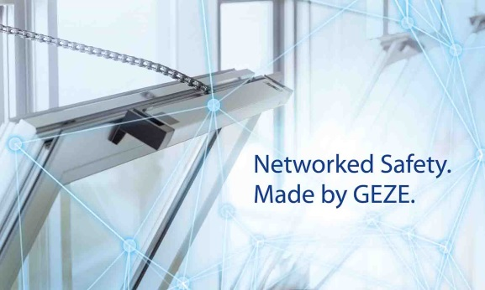
GEZE at Security 2016

27 to 30 September 2016, Messe Essen, Hall 3, Stand 3C71

Leonberg, 20th September 2016

Only a few days until the Security trade fair opens its doors
GEZE is showcasing its system expertise in building networking
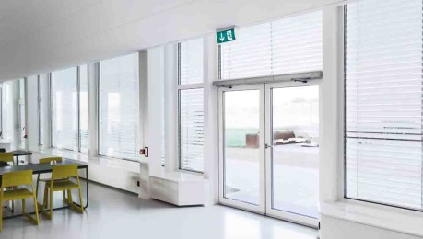
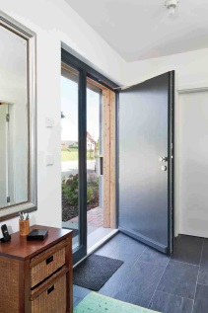
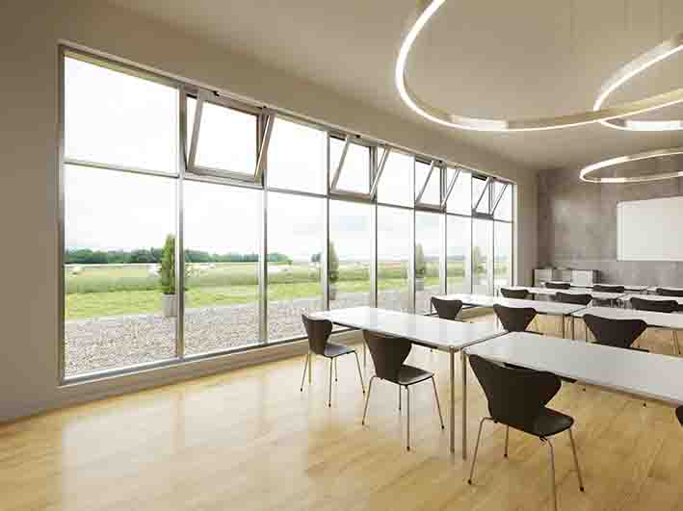

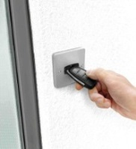
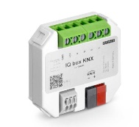
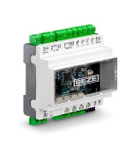

The Powerchain chain drive for large and heavy windows within an RWA system solution. The IQ windowdrives can be integrated into KNX building systems via the interface module IQ box KNX. | Multifunctional swing door system with the “robust” Powerturn drive. With the interface module IO 420, GEZE products and systems can be integrated into network solutions with BACnet. | Entry door solution: The automatic swing door drive ECturn Inside with the stand-alone access control system GEZE SecuLogic GCER 100  Photos: GEZE GmbH

How does the building of the future look like and which requirements need to be fulfilled so that it becomes safer, more comfortable, more efficient and more sustainable to operate it? As a system supplier, GEZE provides answers to these questions through innovative building automation combined with safety solutions for intelligent building networking. Highlights of the trade fair presentation are interface modules on the basis of the BACnet and KNX communication standards.

GEZE demonstrates the integration of door, window and safety technology in “smart” networked solutions. Via the new BACnet interface module IO 420 GEZE products and systems can be integrated directly into the building management system. GEZE also demonstrates the networking of automated door and window systems that are integrated into a building automation system with the KNX standard. The award-winning new interface module IQ box KNX allows direct integration into a KNX building system. Automated doors and windows, smoke and heat extraction systems (RWA) and safety technology can thus be visualised, controlled and monitored from a central point.

Networked system solutions which combine preventive fire protection, emergency exit protection, access control, burglar resistance and automatic barrier-free door control are being presented from the GEZE product range. Visitors to the fair will be able to “experience” complete systems e.g. multifunctional safety doors for larger and smaller buildings, an automatic sliding door solution which – fine-framed – offers increased safety, complete smoke and heat extraction systems (RWA) as well as windows with “intelligent” drives from the IQ windowdrives series.

