PRESS RELEASE FOR PUBLICATION
Leonberg, 23 November 2016
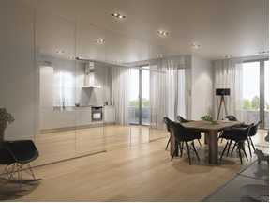

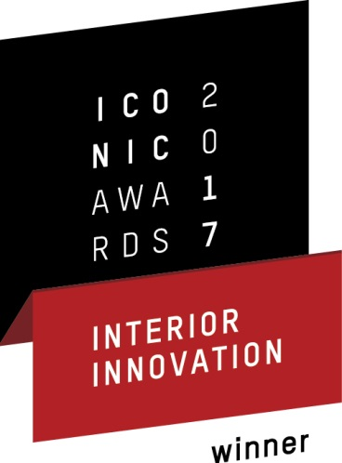

Honoured with the ICONIC AWARDS 2017: Interior Innovation
The design sliding door system GEZE Levolan 120

Finding and rewarding the best in all areas of Interior Design – such is the aim of the 'ICONIC AWARDS 2017: Interior Innovation', one of the most prestigious design awards in the global interior design industry, awarded by the German Design Council¹⁾. The design sliding door system Levolan 120 is the winner in the building fixtures competition category. As an additional honour, Levolan 120 will be presented in the exhibition accompanying the international interiors show imm cologne from 16 to 22 January 2017 in the premises of Kölnischer Kunstverein.

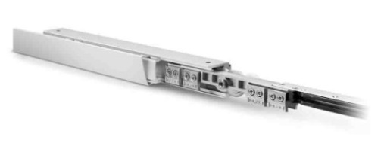
The Levolan 120 shone in assessment criteria such as benefits, design, design quality, degree of innovation, usability, functionality, accessibility, safety and durability. With its streamlined design, and the compact dimensions of the total fitting system, it is perfect for any architecture and installation situation. Thanks to the compact, modular design, it is no larger, yet carries twice the load of its 'little brother', the Levolan 60, and is therefore an optimal solution for heavier door leaves. All-glass or wooden sliding doors with door leaf weights of up to 120 kilograms can be moved with elegant
ease and effortlessly. The whole fitting technology of the Levolan 120 is integrated into the track which is only 50 millimetres high. The Levolan 120 SoftStop draw-in damper, which can also be integrated into the track, provides safety and comfort. The sliding door leaves are guided gently and safely into the end position so that there is virtually no possibility of anything hitting the frame, or any risk of getting fingers trapped. Specially designed carrier rollers ensure an excellent load distribution and smooth running characteristics. Removal protection is automatically activated when the height of the door leaf is adjusted, thus providing additional safety, almost by itself. The clamping roller carriage of the Levolan 120 is designed for glass thicknesses of 10 - 12.76 millimetres. This enables standard glass thicknesses for laminated safety glass to be integrated easily. The Levolan Smart fix installation system makes installation fast and easy.

- The German Design Council organises this competition, thus creating a unique platform for networking architects and property developers with the interior design industry. It was launched over 60 years ago on the initiative of the German Bundestag. Its task is to promote the quality of our living environments through good design in all areas. A highly qualified, independent jury with representatives from the fields of design, trade and media judges the Interior Innovation entries and chooses the winners.

