PRESS RELEASE FOR PUBLICATION
Leonberg, 09/05/2017

INDUSTRY AWARDS 2017 – GEZE among the best
More flexible and sustainable manufacturing with unique combination valve machine
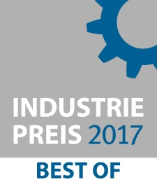
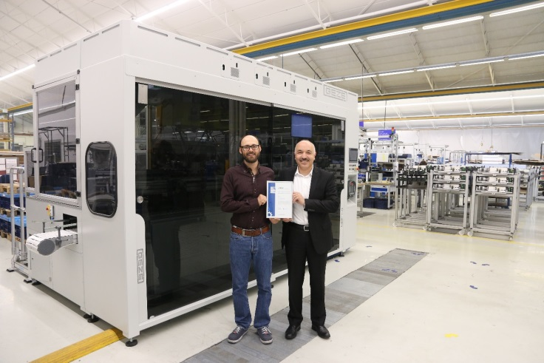
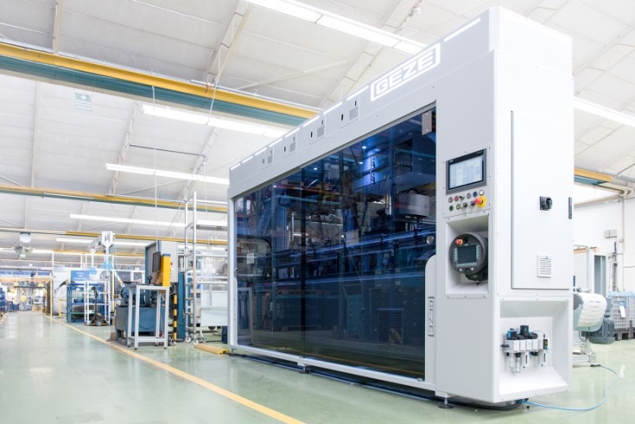

Photos: GEZE GmbH

The GEZE combination valve machine is among the best in the 'Production Technology and Engineering' category in the INDUSTRY AWARDS 2017. Right: Head of Industrial Engineering, Lutfi Bozkurt, and Head of the Process Planning Engineering team, Volker Nepple, with the renowned certificate

The building technology specialist won over the INDUSTRY AWARDS 2017 jury with an innovative solution for the optimisation of measuring, testing and automation technology, and can count itself among the best in the 'Production Technology and Engineering' category.

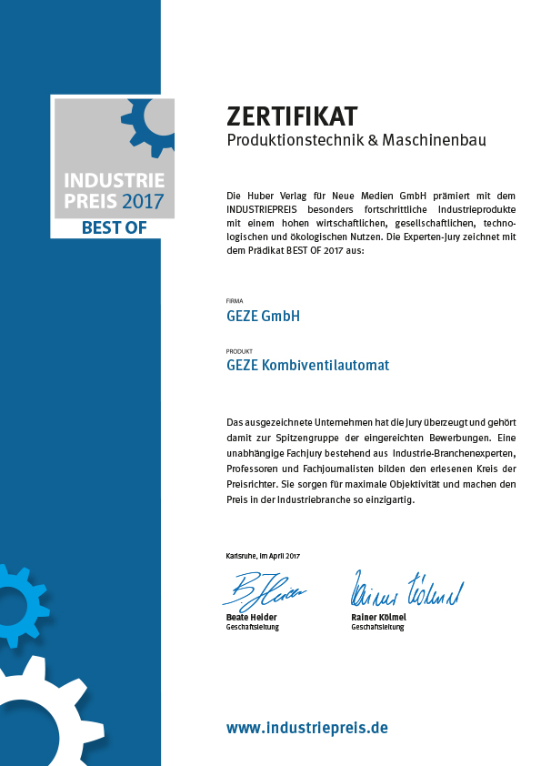
GEZE has perfected installation as well as testing and measuring technology in its manufacturing sector at its Leonberg site, with a combination valve machine that is unique on the market. Using precise automation technology, the new solution makes the manufacturing process more flexible, and therefore reduces the consumption of resources. This makes manufacturing both more economical and more sustainable. The innovative solution developed by GEZE was much appreciated by the INDUSTRY AWARDS 2017 (INDUSTRIEPREIS 2017) jury, and puts GEZE among the best in the 'Production Technology and Engineering' category. The combination valve machine has also been included in the newly published INDUSTRY Best Of list for 2017. Both award winners and particularly advanced submissions for the Industry Awards are listed in this compendium of innovative products and solutions for medium-sized companies¹⁾.

For GEZE, sustainability starts in manufacturing
The combination valve machine turns a pure carrier system, a transport system in manufacturing, into a versatile device. It serves to put components into position, keep them there and fasten or guide them. Different variants of GEZE overhead door closers can be assembled with the same system, without any effort for setting them up. This creates minimum cycle times with maximum process safety, and subsequently, economical and sustainable manufacturing. Compared to the previous space requirements, different automation processes are condensed into a system which is three times smaller. This reduces the area needed for manufacturing and the consumption of materials, saving resources. All elements of the system possess proof of their energy efficiency. Compared to a standard system, energy consumption is reduced by more than 50 per cent. Another special feature of the system is its individual lighting concept: different light colours represent different system statuses. For example, if there is a lack of a certain material, the lighting concept (colour and light pulse) sends a signal to the surrounding area – logistics, for instance – so that intuitive and targeted replenishment is guaranteed.

"Achieving long-term aims and sustainable business have always been a priority for GEZE. This also includes dealing with natural resources responsibly, and the associated verifiable global responsibilities. Our conduct does not only focus on continually improving our products, but also our manufacturing processes," says Lutfi Bozkurt, Head of Industrial Engineering at GEZE. "We are glad to see our latest innovative development in manufacturing rewarded."

- http://www.produktionstechnik-bestenliste.de/#/products/15097-geze-kombiventilautomat

Press contact:  Julia Graf  Tel.: +49 (0)7152 203-505  Fax: +49 (0)7152 203-237  Email: j.graf@geze.com | GEZE GmbH  Reinhold-Vöster-Straße 21-29  D - 71229 Leonberg  www.geze.com
ABOUT GEZE
The GEZE brand stands for innovation and premium quality products, processes and services. GEZE is one of the leaders on the market and is a reliable partner worldwide for door, window and safety technology products and systems. No matter what the requirements of the building are – GEZE realises optimum solutions and combines functionality and security with comfort and design. GEZE door closers open up numerous technical and visual options. Every day millions of people go through doors equipped with the overhead door closers from the TS 5000 series and enjoy the barrier-free convenience of automatic door systems, e.g. the Slimdrive and Powerturn lines. The integrated all-glass design systems are pure aesthetics. GEZE also has a wide product range for window and ventilation technology. Complete "intelligent" smoke and heat exhaust solutions (RWA) and a comprehensive selection of door systems for RWA air supply solutions are also available for preventative fire protection. GEZE's safety technology includes escape and rescue route solutions, lock technology and access control systems. With system expertise, GEZE creates coordinated system solutions that combine individual functions and security requirements in one intelligent system. The latest innovations are a new building automation system and interface modules for integrating GEZE products into networking solutions which turn buildings into Smart Buildings. GEZE product solutions have received numerous awards and can be found in renowned structures all over the world. The company is represented by 31 subsidiaries, 27 of which are abroad, a flexible and highly efficient distribution and service network and almost 2,800 employees worldwide and generated revenues of over 394 million Euros in the 2015/2016 business year. www.geze.com

